Link: https://therealxfr.github.io/islt_4355/about.html

Wireframe: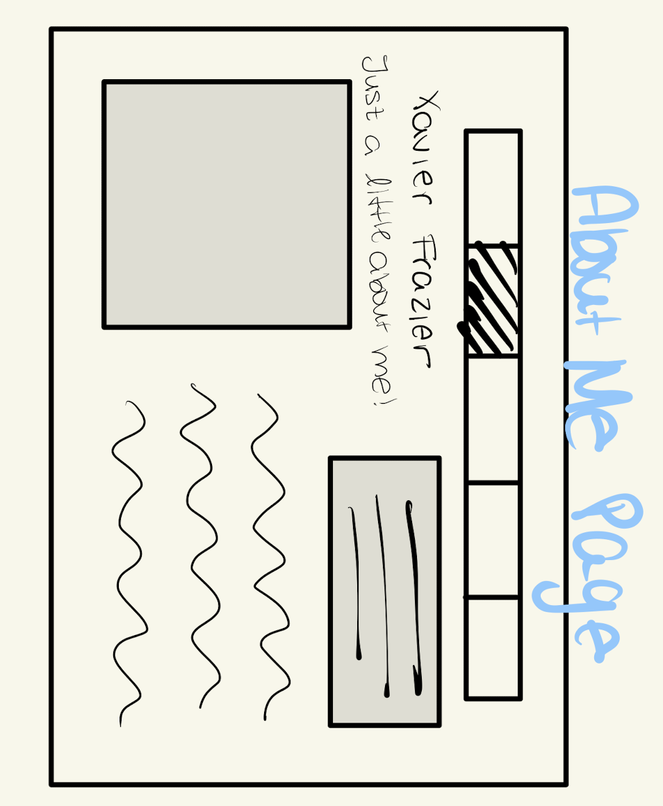

Reflection on Page to Wireframe:
I coded my page to look very similar to my wireframe. I put the picture on the left, and I have my description on the right just as I put in my wireframe. The main differences right now is the alignment of the navigation bar, and my name being placed under the picture versus above. I did that because It felt a little too cluttered above the picture with the “Just a little about me!” The last thing was the quote. I ended up putting it at the bottom of the page instead of the top right corner [in a box]. It just looked cleaner to me and made more sense in the long run.

